Openframeworks

https://forum.openframeworks.cc/t/rebuilding-everything-with-fpic/12074
In 2013, if you wanted to build OpenFrameworks with the -fPIC flag (for buliding a shared library, aka .so file) then you would need to rebuild all the dependenices as well. However, there was no official mechanism for this. Thus, you were left to track down the dependencies and rebuild them on your own.

Linker error when compiling on linux - bugs, errors – openFrameworks
As of 2016, OpenFrameworks uses a system called “apothecary” to manage build dependencies. Through this system, you can add the -fPIC to the “apothecary formulas” for the dependencies in question, and then have the system rebuild them.

AskBre Sep '16
Thanks for the quick reply!
That did indeed fix it for tess2, but apothecary doesn’t seem to have a working makefile for kiss on linux64. In formulas/kiss, the kiss.sh has a
elif [ "$TYPE" == "linux64" ] ; then echoWarning "TODO: linux64 build
But it was a stray kiss.sh laying about which when moved into formulas/kiss gave the error make: *** No rule to make target 'src/kiss_fft.o', needed by 'libkiss.a'. Stop.
What do you reckon? Is there a working formula for kiss on 64-bit linux? Is this 2 up to date? Or how should I go about writing a Makefile catering kiss_fft.o?
arturo Sep '16
the latest apothecary formulas are in their own repo: https://github.com/openframeworks/apothecary 15 there you can find the latest kiss formula: https://github.com/openframeworks/apothecary/blob/master/apothecary/formulas/kiss/kiss.sh 17 also the latest compiled libs are here: http://ci.openframeworks.cc/libs/ 13 in case the settings in the latest formulas are already correct

In 2017, some people attempted to get OF build as a dynamic library
https://forum.openframeworks.cc/t/how-to-build-of-to-a-shared-library-dynamic-library/26873
That thread references this attempt on windows: (2015)
https://forum.openframeworks.cc/t/build-of-as-a-dll-under-windows/19019
and this attempt on OSX using Xcode (considering VST applications) (2016)
https://forum.openframeworks.cc/t/can-i-change-empty-example-xcode-project-output-to-dylib/25456/3

https://forum.openframeworks.cc/t/build-of-as-a-dll-under-windows/19019/2
nil May '15
I think Arturo did something already to build openFrameworks as a DLL:
arturo Apr '15
i added some flags to optionally compile OF as a shared library (needed for emscripten) so it might be even easier to setup on the makefiles for 0.9
[arturo’s post is from this thread: Can openFrameworks do live coding and how - beginners – openFrameworks]

https://forum.openframeworks.cc/t/how-to-build-of-to-a-shared-library-dynamic-library/26873/2
That post by arturo is referenced in this thread again. The OP of this thread wonders aloud what exactly these flags are, but there is no response.

Linker error when compiling on linux - bugs, errors – openFrameworks (referenced earlier)
Later posts in this thread are from May, 2017, and imply that it is no longer necessary for some people to compile with -fPIC. It is possible that this is because in OF 0.10, the dependencies are compiled with -fPIC from the get-go.

From looking at a release copy of 0.10, the -fPIC flag is not set for the linux platform by default in 0.10. However, it is set for other linux-based platforms, like android, and linux-arm

Build Strategy:

RubyOF should vendor the version of OpenFrameworks used.

Try downloadable copy from the website first, rather than the github copy (smaller, because it doesn’t have the full development history)

If the dependencies from this build don’t work, then I’ll have to build them myself using apothecary.
In this case, rather than using the

(I think I have a source that says that the download dependencies script pulls from some location online which is updated by apothecary? So basically, instead of doing that, I need to patch in my own custom built libraries.
HERE IT IS!

From the Apothecary readme on Github:
https://github.com/openframeworks/apothecary

Built Libraries
Updates on master branch are automatically pushed to http://ci.openframeworks.cc/libs/ , and downloaded by running the download_libs.sh scripts in openFrameworks if working from git.

https://unix.stackexchange.com/questions/116327/loading-of-shared-libraries-and-ram-usage
This is a great explanation of how the memory associated with a dynamic library is shared between multiple processes. In particular, it explains how the -fPIC flag helps a linux system accomplish this memory sharing.

- Test building the core
Rather than editing core files, the two build variables that need to be set to build OF core into a shared library (dynamic library) can be set on the command line using environment variables
env SHAREDCORE=1 CFLAGS=-fPIC ./compileOF.sh -j4
BUT the weird thing about this result, is that the output file is still called libOpenFrameworks.a even though it is a shared library.
Will need to manually change the extension. In the grand scheme of things, that’s not that big of a deal, and certainly something I can do in my Ruby build system.
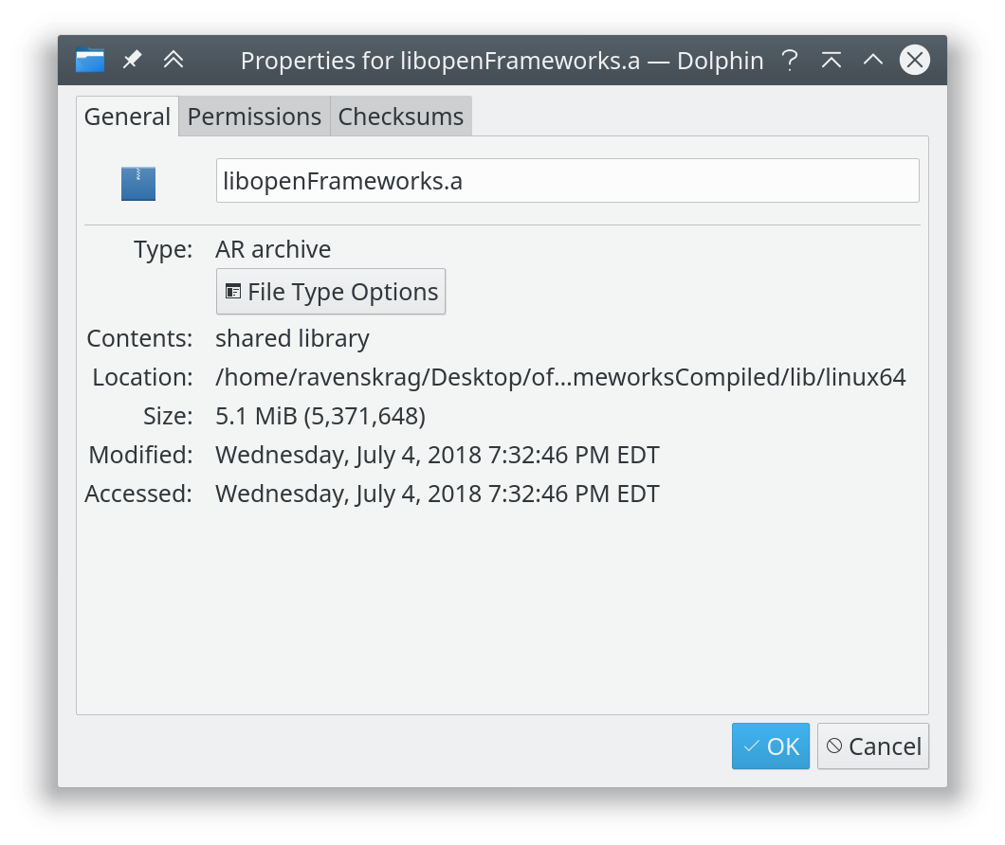
(See the “Contents” field in the screenshot above, from KDE’s Dolphin file manager)

NOTE: SHAREDCORE variable is used in the following file
openFrameworks/libs/openFrameworksCompiled/project/makefileCommon/compile.core.mk
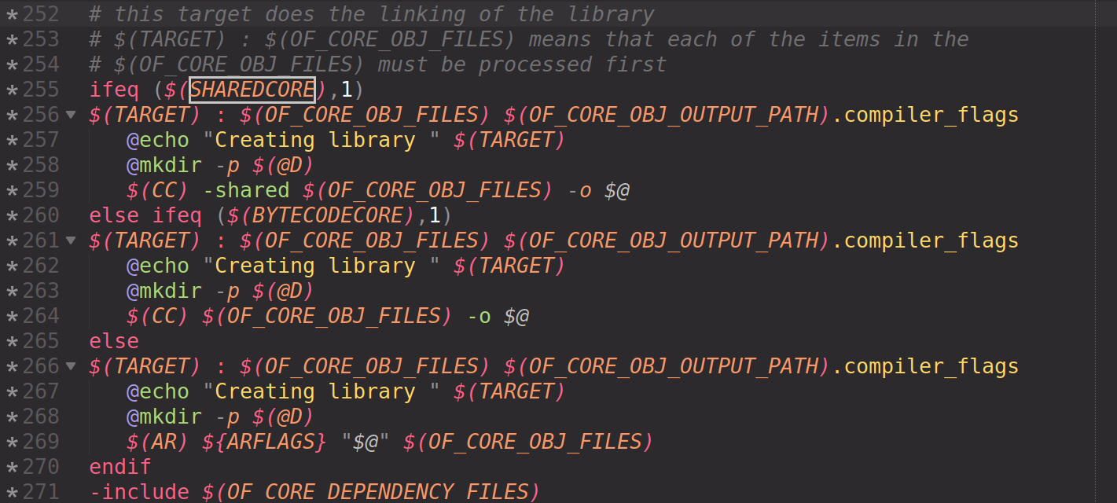

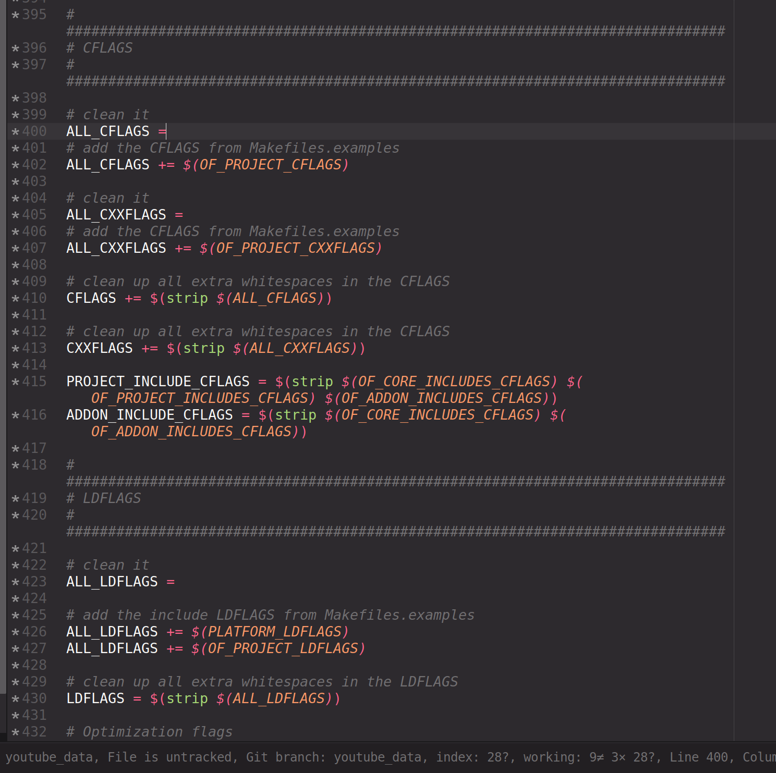
CFLAGS variable is declared in this file
openFrameworks/libs/openFrameworksCompiled/project/makefileCommon/config.project.mk

you can see that the variable is set using “+=”
aka, it is not cleared by the build system.
It is also composite of various other variables, that seem like they are OF-specific. By setting CFLAGS, rather than one of these other variables, we can set -fPIC the way we need to, without having to muck with the internals of the OpenFrameworks build system.

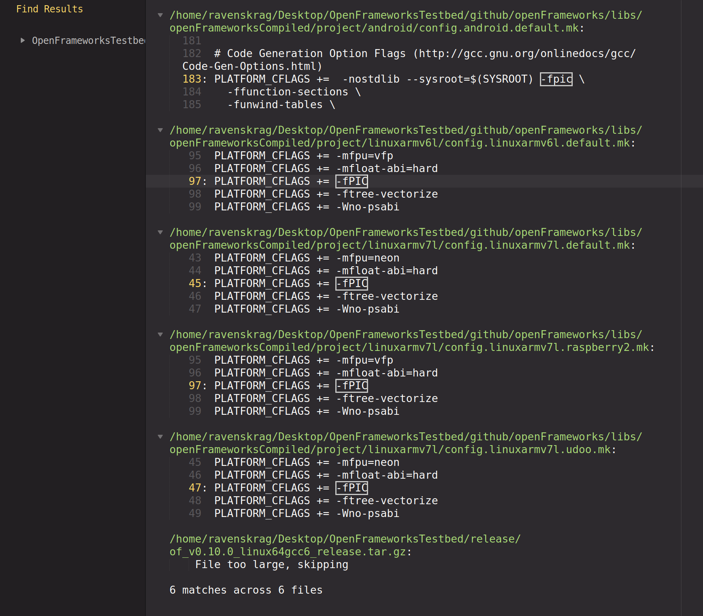
-fPIC is not set for standard linux (neither 64 bit nor 32 bit) but it is set for ARM and android

- basic OF examples
  - examples build just fine, when building against the normal static library. Don’t want to have to change how OF projects build, so I’ll just let the pure C++ stuff build against the same old static library as always.
- some addons
- examples for the addons
- the OF 0.10 inside of RubyOF
need to set dynamic library path using the “-l” flag.
e.g.) -lfmodex flag with make the program look for a file called libfmodex.so in the paths specified by -rpath. This needs to replace the current build process, which is to statically link against libopenFrameworks.a
Should probably figure out why there is also a -L flag being used to set something related to fmodex as well.
Currently building OF core as a static library with -fPIC, as that is the easiest set up to use. Perhaps later down the line I will try to compile the core as a dynamic library, in the hopes of reducing memory consumption or something.

ofxDatGui apppears to be broken. Can’t build examples, because “string” can not be found.
Likely, the standard namespace is no longer being included by default, as expected by this older addon. Maybe I can download a newer version of the addon? But if not, I’ll try to get by with some of the other GUI libraries.

There is indeed a commit in ofxImGui that says that std namespace is not included anymore.

 prisonerjohn committed

Added std namespace across classes since it's not implicit anymore.
SHA 4a08e68df73e35d85671917a27b415fb823af5e6

“develop” branch of ofxImGui is currently the only branch I can get working:
SHA: 51c5d083253fe401571f6d33bb581c3944b2c6be
notice that this branch contains a commit that updates the examples.
As I’m testing whether or not the addon works by whether or not the examples work, this explains a lot.

AH! There is a “dev” branch for ofxDatGui that has an update for OF 0.10
This branch appears to work with the current build environment, as expected.
SHA: e39a6e9f5dd209e9149eea76679f8743d4b95f19

Additional Reading

What is the apothecary exactly? - general discussion – openFrameworks
openframeworks/apothecary - Libraries.io

Link additional dynamic libraries on OSX
Dynamic Libraries for OSX addon - extend – openFrameworks
linking dynamic libraries etc. to executable bundle made easy - advanced – openFrameworks

Link additional dynamic libraries on Linux
Dynamic library path hardcoded into executable - linux – openFrameworks
How to use shared object with qtcreator/linux OF? - linux – openFrameworks
Use a dynamic library with OF - advanced – openFrameworks

Matrix multiplication order - general discussion - openFrameworks

NzNico Feb 11
For some reason, I’m working with gl 3.3 with the methodologie described by the website openGL tutorial, which implies no use of the matrix stack, so I send the transformations as uniform matricies.
I was wondering why were the order of the * operator inverted in OF, It seem to be a choice of usage. Anyway, it’s fustrating to write M * V * P where I usually write P * V * M in my shaders or with glm. I spend a lot of time to understand why my projection matrix was behaving weidly.
Thanks

arturo Feb 11
also from next version (which is near to be released) the default vector math library will be glm so the order of multiplication will be the same as glsl

arturo Feb 12
it should be ready in march. ofMatrix3x3 has never been very complete and it’s weirdly implemented. For example in you PR you need a switch case to access the different members to set the columns which can be slow. That’s one of the reasons why we moved to glm, i would use glm if i would be doing any addon today

About Apothecary

Intended to be run from inside the OF base directory, but I’ll just run it as it’s own stand-alone thing, and then copy in the relevant libraries I need.

Just need to rebuild kiss and tess2.

From the base directory of the github repo, you can rub apothecary like this:
./apothecary/apothecary update kiss

take note that “update” is (download, build, and copy), but NOT clean
thus, you may need to explicitly run “clean” occasionally when rebuilding
see readme file in Apothecary repo for more details.

This is much cleaner than making / maintaining my own system to do this dependency downloading / patching.

